- The dataset that you are using, and the source for it. Dimensions of the dataset, and the specific dimensions that you plan to use for unsupervised learning.
I am using the data of the geyser “old faithful” , a popular dataset for cluster visualization.
Two dimensions were used for unsupervised learning ->
Eruptions: The duration of the eruption in seconds
Waiting: The time from the current eruption to the next eruption
An unnamed column of ID of observation was dropped / not used
- b. Parameters for K-means, and results in visual form
I used elbow method first to find optimal cluster numbers which was 2 clusters.
2 clusters were used with 100 number of iterations.
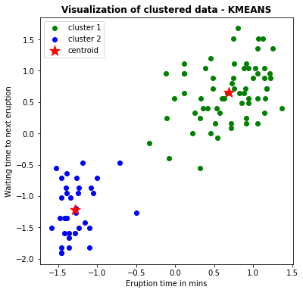
- c. Name of the density-based algorithm that you've chosen. And parameters for density based clustering, and results in visual form
DBSCAN (Density-Based Spatial Clustering of Applications with Noise) was used with default parameters.
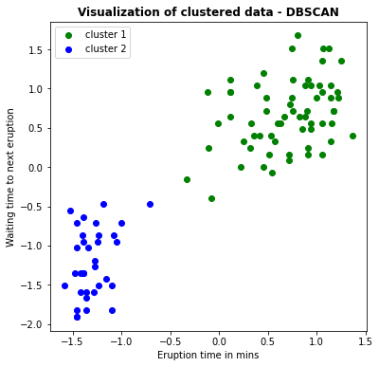
- d. Comparison of b and c (Above steps, max write 5 lines) and cover why two algorithms performed in a different way. Which one you'll prefer for your specific dataset and why.
DBSCAN and K-means both performed in a similar manner but DBSCAN has less outliers in the mid-point of the dataset which explains how it filters out noise well.

